**Varun Khadayate | A016**

**Professor Dr. Archana Gulati**

**Usability Design of Software Applications (UDSA)**

**4th November 2022**

**Assignment 1**

**Research on 2 prototyping tools**

**Introduction**

Prototyping is a process in which design teams ideate, experiment with, and bring concepts to life, ranging from paper ideas to digital designs. Design teams experiment by turning their ideas into physical prototypes, which might range from paper to digital. For capturing design concepts and user testing, teams create prototypes with varied levels of realism. You may improve and evaluate your designs using prototypes, allowing your company to release the proper products. The fourth stage of both design sprints and design thinking is prototyping. It's a crucial component of user experience (UX) design that typically follows ideation, in which you and your team have developed and chosen concepts that can meet users' needs. In prototyping, you create a straightforward experimental model of your desired product so you can evaluate how well it corresponds with user feedback. A key characteristic of prototyping is that prototypes are created without a single line of code. There are plenty of prototyping tools to help designers link together artboards, creating an interactive, clickable experience without the need of a developer. This helps decrease costs, as designers can create clickable prototypes without the need for development efforts. In other words, it’s smart to test your prototype with users and stakeholders to iron out any mistakes before you invest the money, time, and human capital on engineering a design solution.

Prototyping requires prototyping tools. While there are many tools out there, we will be discussing about Figma and Webflow, their characteristics, pros, cons, and their difficulty level.

**Figma**



**About Figma**

Figma is an online tool for collaborative interface design that also has offline functionality made possible by desktop programmes for Windows and macOS. Figma combines a few vector graphics editors and prototype tools, with a focus on real-time collaboration and a focus on user interface and user experience design. Real-time viewing and interaction with Figma prototypes on mobile and tablet devices are made possible by the Figma mobile app for Android and iOS.

**Features in Figma:**

1. *Collaboration*

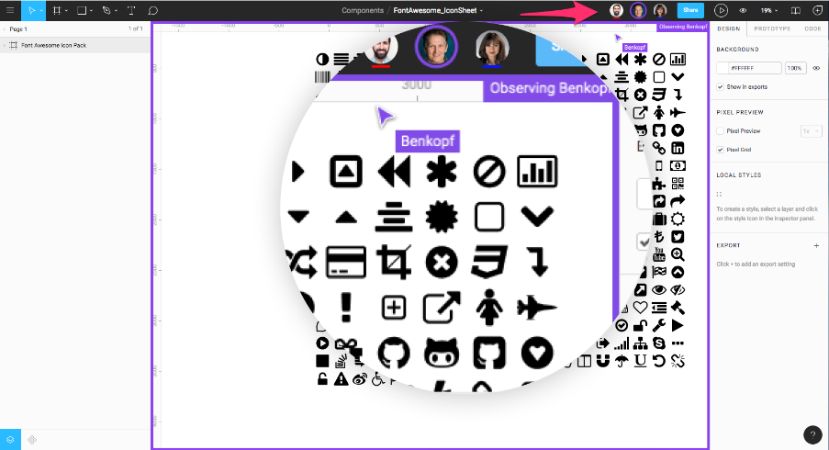

Teams can work together in Figma just like they would in Google Docs because it is browser-based. A round avatar of a user viewing or editing a file is displayed at the top of the programme. Additionally, each person has a labelled cursor, making it simple to see who is doing what. When you click on another person's avatar, you can zoom into anything they are now viewing.

Real-time file collaboration reduces "design drifting," which is described as misinterpreting or deviating from an established design. When an idea is generated and swiftly implemented while a project is in process, design drifting typically occurs. Unfortunately, this frequently results in departing from the original plan, which creates friction and extra work. By just opening a shared file, a design lead may use Figma to check in and see what the team is designing in real time. This feature enables the design led to step in, correct the course, and save countless hours that would have been otherwise spent if a designer somehow misinterprets the brief or user story.

1. *Sharing*

Additionally, Figma enables permissions-based sharing of any page, frame, or file (called an artboard in other design tools). A person clicking on a share link for a frame on a page will launch the browser version of Figma and load a zoomed-in view of the frame.

1. *Code Snippets*

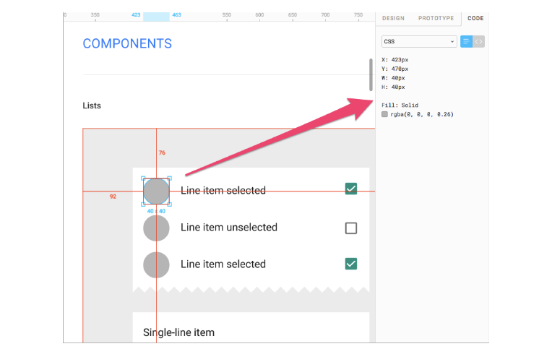

Figma displays code snippets on any selected frame or object in CSS, iOS, or Android formats for developers to use when reviewing a design file. The design components can be inspected by any developer in any file they can view. There is no need to use a third-party tool to get the information. Even so, Figma has full integration with Zeplin if teams want to do more than simple measurement and CSS display.

1. *API and 3rd party integrations*

Figma now has developer APIs to allow true integration with any browser-based app. Companies are using this to integrate real-time displays of design files in their apps. For example, Uber has large screens displaying design files “live on air” around their company. Designs are shared, and feedback is welcome from anyone in the company.

1. *File Versioning*

File versioning is a process that saves your work as multiple versions throughout the editing process. These versions are saved in different locations to make sure they're never lost. With versioning, you can always go back and recover your original work with no loss of data. Any uncertainty surrounding live file updating is further mitigated by Figma’s built-in versioning system. At any time, a designer can create a named version and description of a Figma file; this can be done immediately after agreed changes are made to a design. The live file in the shared environment will not be affected until changes are deliberately committed to the original version. It’s also possible to restore any automatically saved versions to create a duplicate or overwrite the original.

**Advantages of Figma**

* *Easily Create Website Mock-up***-** The most obvious advantage of Figma is that you don’t need to know how to code. You simply drag and drop objects onto the canvas to build your prototype.
* *Simple Interface***-** If you’ve ever tried to use Photoshop before, you probably found it difficult to navigate through the interface. However, Figma is much easier to use because it only requires one click to add an object.
* *Supports Both Desktop Computers and Mobile Devices***-**You don’t need to worry about compatibility issues if you choose Figma. Since it supports both desktop computers and mobile phones, you can easily access your files from anywhere.
* *Responsive Designs***-** When you’re creating a website, you’ll often need to resize elements on your page. If you’re not careful, these elements may end up looking messy when viewed on a smaller screen. That’s why responsive design is so important. But with Figma, you don’t need to worry. The program automatically adjusts your layout according to the size of the screen.
* *Support Multiple Platforms***-** Figma is compatible with multiple platforms including Windows, Mac OS X, iOS, Android, and Linux. So, there’s no need to worry about compatibility problems.
* *Share Files Quickly***-** Once you finish designing your project, you can share it directly from the browser window. This makes it easy to send your designs to clients without having to save them first.
* *Customizable Templates***-** With Figma, you can customize templates based on your needs. For example, you can change color, fonts, and backgrounds to make your own unique style.
* *Export as PDF***-** Figma allows you to export your projects as PDF documents. This means that you can print out your designs and hand them to clients.
* *Collaborate With Others***-** Since Figma is cloud-based, you can work together with others by sharing your files online.
* *Easy To Learn***-** While some people find Photoshop intimidating, Figma is very easy to learn. Even beginners will be able to use it within minutes.
* *Powerful Tools***-** One of the best features of Figma is that it comes with several powerful tools. These include the Pen tool, Shape tool, Text tool, and Magic Wand tool.
* *No Need to Save Your Work***-** In addition to being simple to use, another great feature of Figma is that there’s no need to save your work. Once you’re done editing, you can immediately preview your changes in real-time.
* *Works Well On All Devices***-** Unlike other programs, Figma works well on all devices including desktops, laptops, tablets, smartphones, and more.
* *Fast Loading Speed***-** Another reason why Figma is such a popular choice among designers is that it loads quickly. It takes less than two seconds to open a new file.
* *Cross-Browser Compatible***-** The last thing you want when working on a project is to have to deal with bugs. Fortunately, Figma has been tested thoroughly across different browsers. So, you won’t experience any glitches while using it.
* *User-Friendly Interface***-** The interface of Figma is extremely user friendly. You don’t even need to know how to code to create something amazing.
* *Easily Accessible***-** Even though Figma is relatively new, it already has over millions of users. And this continues to grow every day.
* *Great Customer Service***-** If you ever run into issues or have questions, their customer service team is always available to help.
* *Highly Recommendable***-** When it comes to choosing between Adobe Creative Cloud and Figma, we highly recommend Figma. Not only does it come with many useful features, but it’s also much easier to use.

**Disadvantages to Figma**

* *No Version Control***-** Tracking all the changes that have been made is difficult because version control is lacking.
* *Limited Customization Options***-** Although Figma offers a lot of customization options, it still lacks certain ones. For instance, you cannot add custom shapes, gradients, or patterns.
* *Cannot Work Offline***-** Like most desktop applications, Figma requires an internet connection. This makes it impossible for you to work offline.
* *Lacks Collaboration Capabilities***-** Because Figma is not compatible with other software like Sketch, you’ll have to share your files online. This could cause problems if you’re collaborating with someone who uses a different program.
* *Prototyping process***-** Some people prefer to see what they’re creating before starting to make it. Unfortunately, Figma does not offer video tutorials or animation capabilities.
* *Default settings***-** Since Figma was designed primarily as a prototyping tool, it comes with default settings that may not be suitable for everyone.
* *App restart is required***-** There are times when the application will crash or freeze. To avoid these situations, you should close the application and reopen it later.
* *View options***-** For a casual user, Figma’s view options need to be improved so that users can easily understand it and use it to their advantage.
* *Usability issues***-** Some of the usability issues can be seen from time to time. Some of the tools in Figma aren’t easy to discover in the first place. Furthermore, in some cases, interface changes are not notified of these changes, so you are forced to figure out how the changes work as they are implemented.
* *Text capabilities***-** The text capabilities of Figma are lacking. There needs to be a way to search for text in the application.

**Webflow**

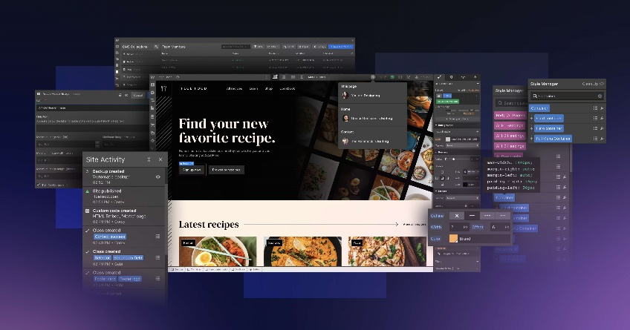

**About Webflow**

An American business called Webflow, Inc. with headquarters in San Francisco offers software as a service for creating and hosting websites. Their visual editor online platform enables customers to create, develop, and design websites. With browser-based visual editing software, designers may create responsive websites using Webflow, a SaaS application. Webflow automatically generates HTML, CSS, and JavaScript while designers work with the programme. Webflow-created websites are hosted on Fastly and run-on Amazon CloudFront. A CMS is included in the all-in-one platform known as Webflow. It doesn't need any further plugins.

**Features in Webflow:**

1. *Provides CSS properties*

Helps users visually develop CSS grid-powered layouts and access multiple CSS styling properties. Even more, this feature allows users to create effects on their website elements with any of the eight CSS filters provided by Webflow.

1. ***Responsive images and website templates***

This software allows developers to build responsive websites that can adjust to multiple device settings. More so, the software automatically optimizes and scales inline images at different resolutions and for various device sizes. Also, users can either build websites from scratch or user any of the responsive website templates that Webflow offers.

1. ***Allows exportable custom codes***

Webflow writes semantic and W3c compliant codes for users, which gets rid of the need for inline classes. Even more, the software enables users to export images, CSS, and HTML as ZIP files from their preferred browser. Plus, users can also add custom code for certain parts of a page, the entire page itself, or even the whole website.

1. ***Enables users to intuitively develop responsive and flexible layouts***

Using Webflow's CSS3 flexible boxes. Also, the software allows users to make key colors global, which updates every instance of that color whenever it is modified.

1. ***Allows for motion design***

With Webflow, users have access to 3D animations and transformations, which allows them to add new dimensions to their website designs without having to write code. Users can also easily design animations and interactions on their website without code.

1. ***Comes with content templates***

Webflow has a REST API that allows users to create a collection of content as well as delete, update, and add items to this collection from their terminal. When users create a collection, the software automatically produces a template page where users can modify the display of that content. The template is applied to every content in the collection, allowing users to build multiple pages simultaneously easily. Web developers can also filter dynamic content so that only blog posts or featured content related to a specific topic are displayed. Even more, with sorting, users can choose for content to be displayed from a particular date range.

1. ***Comes with a website editor***

This content management software allows users to easily update images and texts from a live website without having to go to a complex backend.  Even more, with Webflow CMS hosting, users, as well as their collaborators and clients, can review submissions from website forms from within the Editor panel. They can also download the lists as CSV files.

1. ***Allows for custom branding***

Webflow offers CMS white-labeling functionalities that allow users to put their logo or that of their clients in the CMS. More so, users can white-label form submission notification emails.

1. ***Makes it possible for designers to set up client billing***

Users from withing Webflow can directly bill clients for monthly hosting. Users can also create custom 404-page designs to help their customers recover from 404 "page not found" errors. Even more, the software allows users to upload custom designs for their web clips and favicons. Additionally, when users are working on multiple projects, they can organize them using folders. Plus, the software allows users to export CSS and HTML and use them as they please. Users can also set up password protection on single pages or their entire website, allowing them to design their page or website as desired before making it live. More so, users with teams can lock projects to ensure that teammates do not accidentally delete pages or sites. Plus, the software automatically backups user's websites and allows them to restore it whenever they want. And current versions of websites are also saved when users restore older versions.

1. ***Allows multiple integrations***

Webflow integrates with multiple platforms for improved functionalities. With the software's integration with Google Analytics, users can track how end-users get to their website, their activities, how long they spend on the site, and more. Users can also purchase custom domains from within the software using Google Domains, without worrying about A-Records, CNAMES, or DNS. Furthermore, with Google Optimize integration, users can run A/B tests as well as other multivariate tests on their pages. Even more, using Web flow’s Mail Chimp integration, users can automatically build email subscriptions lists. Plus, users can also connect their website forms with other design apps, like Asana and Slack, using Web flow’s Zapier integration.

**Advantages of Webflow**

* You can use Webflow to create unique, highly customized, and impactful designs – lots of customization options are available.
* A large selection of high-quality free and premium templates is provided (1,000+).
* Webflow sites are all fully responsive and display nicely across all device types.
* There is an enormous range of typefaces available out of the box in Webflow.
* Webflow’s ‘Logic’ tools allow you to make the most of email submissions and the workflow of your organization.
* Webflow’s ‘interactions’ JavaScript tool is easy to use and can help you produce extremely impressive page load, scroll-based and mouse-hover website animations.
* Good autosave, backup and version history features are built into the platform.
* There is a wealth of high-quality learning materials available for the platform via its ‘Webflow University’ resource.
* Capturing custom data and images for product customization purposes is straightforward.
* Webflow provides an automatic sales tax calculation feature for the US, Canada, the EU, and Australia.
* It’s east to build, style and reuse forms in Webflow.
* It gives you a comprehensive set of SEO options.

**Disadvantages of Webflow**

* The pricing structure is very confusing.
* The learning curve is steep by comparison to other website building tools – despite claims otherwise, it’s more suited to a target market of developers rather than web design novices.
* Traffic limits are applied to its plans — the highest number of visitors you can have on a Webflow site without having to negotiate a bespoke deal is 250,000.
* Despite its the ‘no-code’ emphasis, some understanding of CSS and HTML is essential to getting the most out of the Webflow designer. With many other website builders, you don’t need any coding knowledge at all to use them.
* It doesn’t let you switch templates.
* There is no Webflow mobile app for editing your site on the go.
* The range of ready-made image galleries on offer is very limited compared to many other platforms.
* If you’re a high-output blogger, or need to create a lot of dynamic content, the limits that Webflow places on the number of ‘CMS items’ could prove problematic.
* There’s no Yoast-style SEO plugin for Webflow available.
* Users based in the European Union may encounter GDPR headaches if they store user data on Webflow.
* The ecommerce features are limited: there’s no abandoned cart saving tool, no multi-currency features, no POS functionality, drop shipping apps are in short supply and only two payment gateways can be used.
* There’s no built-in cookie consent mechanism.
* A limited number of integrations are available for Webflow; and in fact, its integrations library is not a fully-fledged app store. Many of the integrations on offer are general third-party tools rather than Webflow-specific integrations and plugins.
* Customer support is email-only on all plans except ‘Enterprise.’

**Conclusion**

Therefore, Figma and Webflow are two design tools with enormous promise. It is incredibly challenging for designers to choose which feature to employ because they constantly introduce new features and enhance existing ones. In the end, everything comes down to the designer's preference. While some people favour plugins, others are more focused on teamwork. Vector networks in Figma may be easier to draw but less accurate and rigorous than those in other design tools. The trade-off between performance, functionality, and features determines which of these two tools should be used. It also depends on outside variables including the size of the team, the accessibility of operating systems, and the capacity for collaboration. However, based on my personal experience, I advise picking Figma for your upcoming design task!